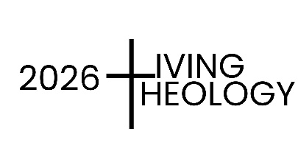

Our Father?
The Shadow of the Father. Reimagining Fatherhood
St Luke’s Retreat Centre
1 – 3 September 2026 (09.30 – 15.30 daily)
REGISTRATION FORM

Please complete this e-form, save and send back with your proof of payment, as an attachment, to pdo@cdpe.co.za;
Surname
First Name |  |  | Title
Organization
Contact details
Telephone | Home | Work | Cell
Address
Address |  |  | Postal code
e-mail
Any special dietary or access requirements.
INVESTMENT | EFT/Cash on arrival | In full by  15 Aug 2026 | After  15 Aug 2025
Course Fees for three days | Including Tea and Lunch | R 1490 | R 1790
Pensioners (over 65) and students | Including tea and lunch | R 1350 | R 1550
Course fees and accommodation | All-inclusive from evening of 31 Aug to afternoon 3 Sep | R 3150 | R 3450
Course one day only | Including tea and lunch | 650 | 650
TOTAL AMOUNT PAID | Tick the required booking and total amount due
EFT payments should be made prior to the event, and proof thereof emailed to pdo@cdpe.co.za
Our banking details are:
Account Name: Diocesan Catholic Centre
Bank: Standard Bank
Branch Rink Street Code 050417
Account No: 080291562
Reference: WLT PE + surname of participant (NOT the name of your organisation)

